**Assignment 1**

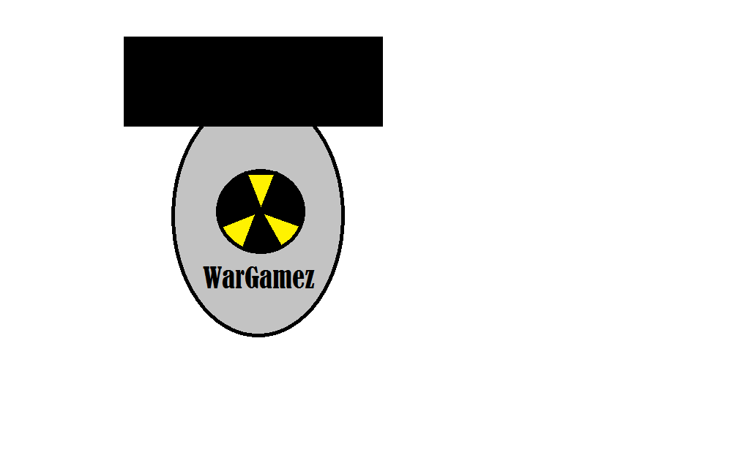

**Table of Contents:**

Page 1: Title and logo

Page 2: Table of Contents

Page 3: Version history, Detailed Game Description, Controls, and Interface Sketch

Page 4: Screen Descriptions (Start State and Gameplay State)

Page 5: Screen Descriptions (Game-End State), Characters/Vehicles, Enemies, Scoring, and Sound Index

Page 6: Art / Multimedia Index (bullet image, grass image, tank mesh, bomb mesh, wrench mesh)

Page 7: All Assets Used

**Version History:**

Version 1 – October 4th 2015

**Detailed Game Description:**

Move forward as a tank blowing up and dodging countless bombs and collecting wrenches along the way, scoring points as you go along.

**Controls:**

WASD – Forward, left, back, right

Mouse 1 – Fire shot.

**Interface Sketch:**

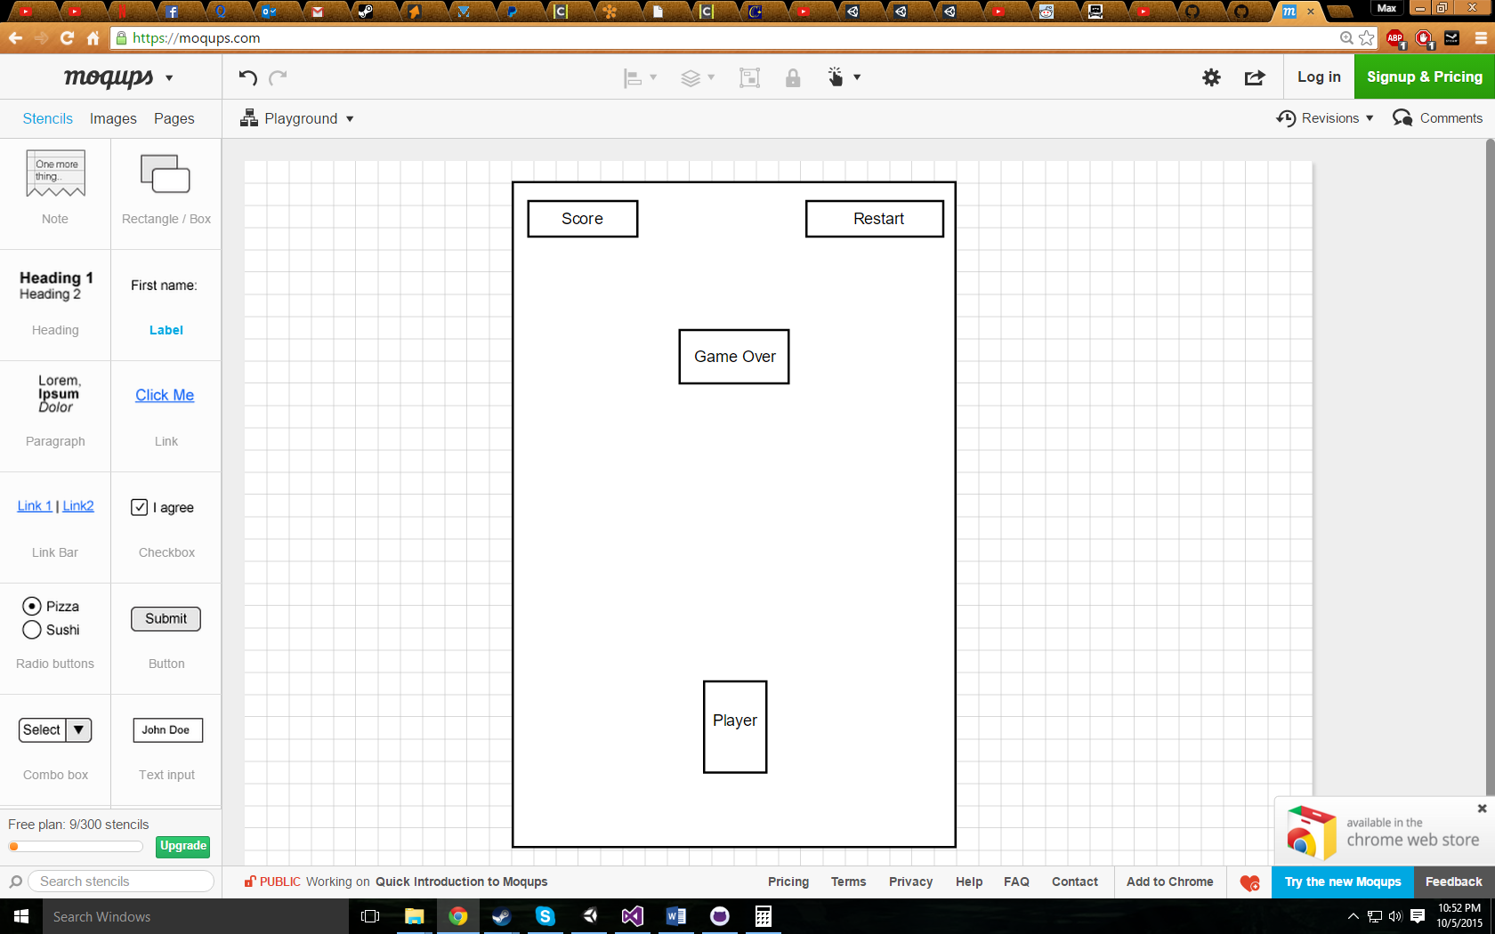

**Screen Descriptions:**

Start State:

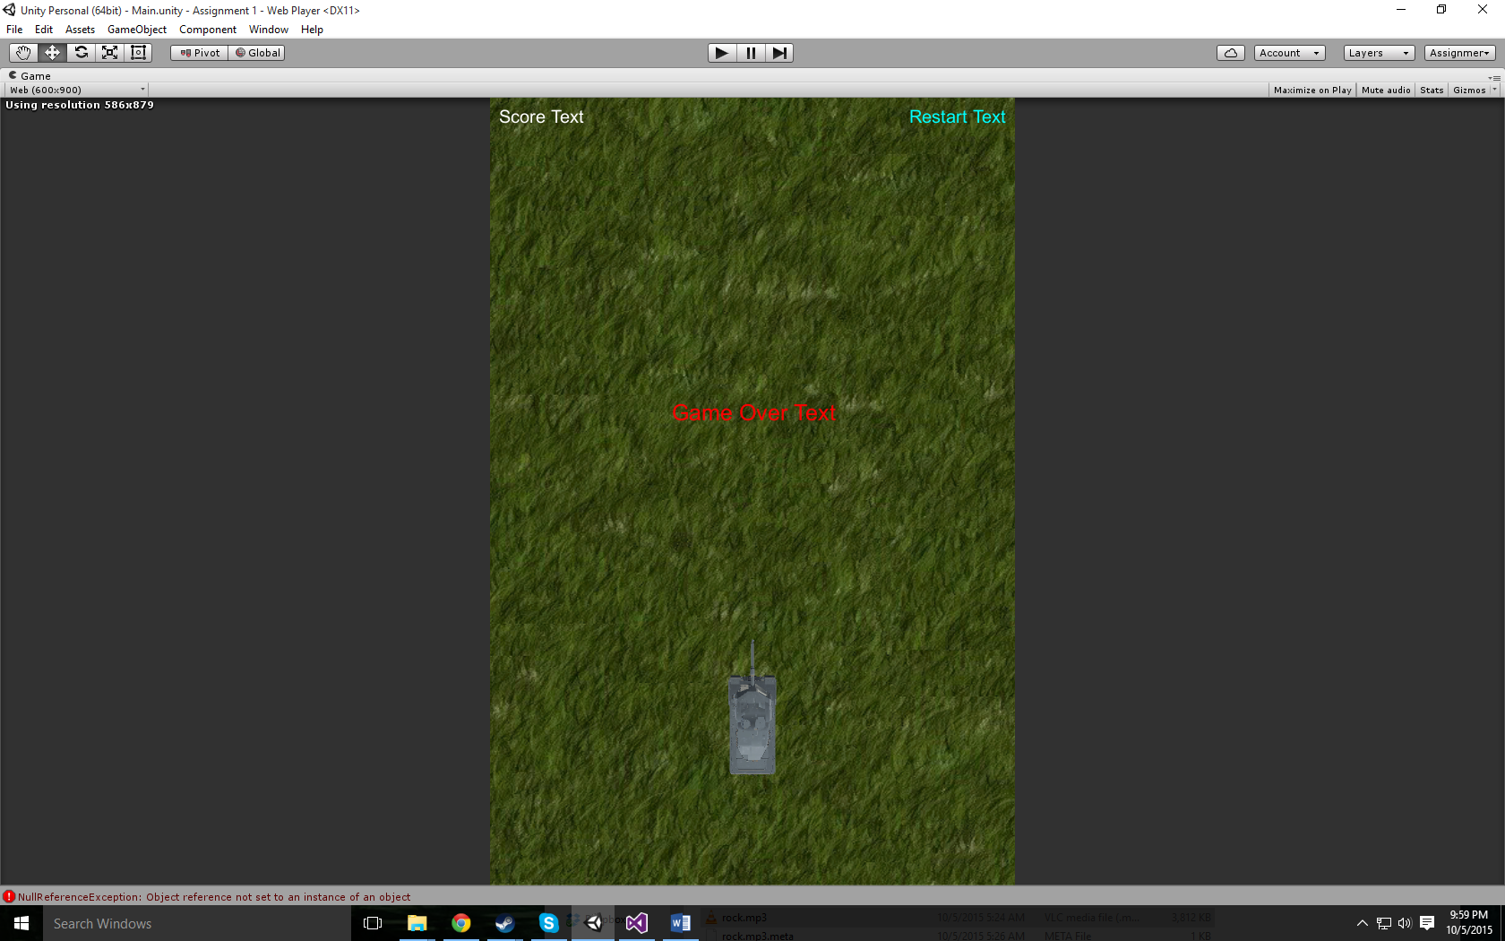

Gameplay State:

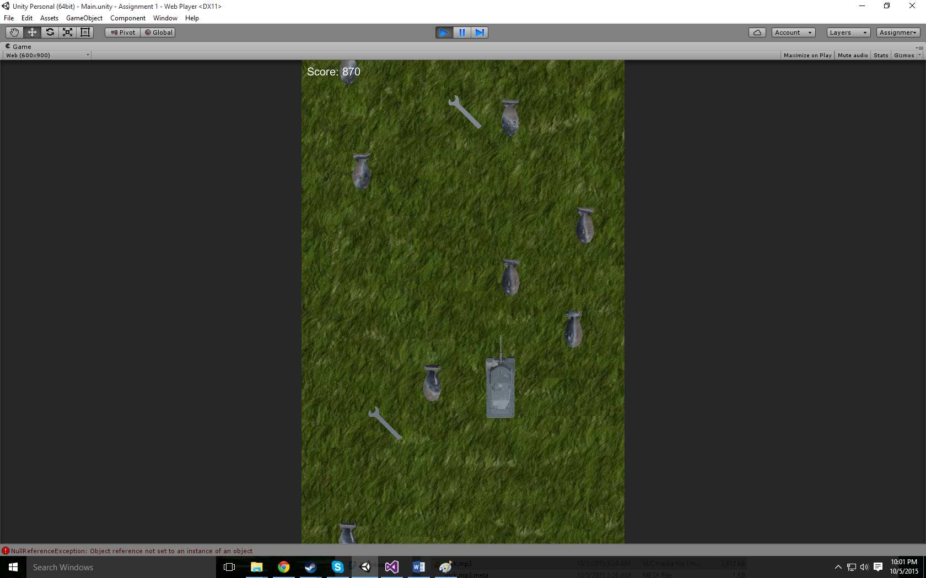

Game-End State:

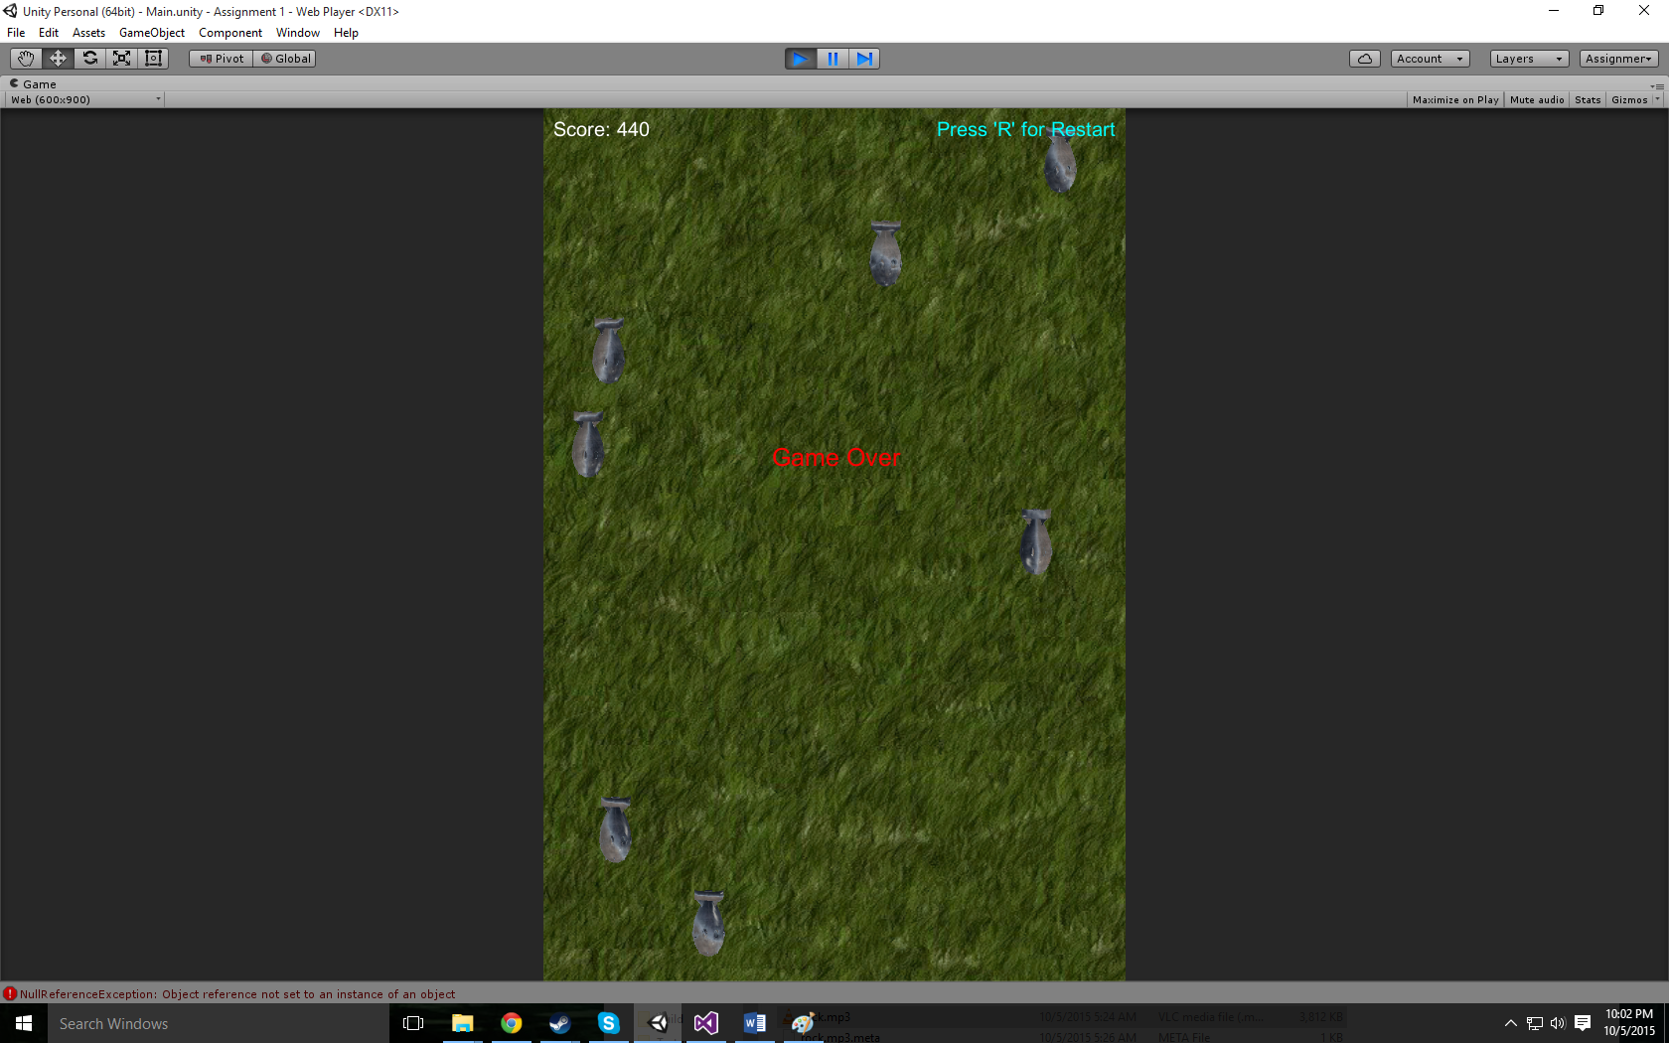

**Characters / Vehicles:**

Tank Player – moves forward, back, and side to side.

**Enemies:**

Nuke Enemy – constantly scrolling down towards the player in random x values.

**Scoring:**

10 points – Shoot nuke

200 points – Collect wrench

**Sound Index:**

Cat meow – fire bullet

Dog bark – collect wrench

End Explosion – You blow up

Impact Explosion – Bomb destroyed

Rock – Game soundtrack

**Art / Multimedia Index:**

Bullet image:

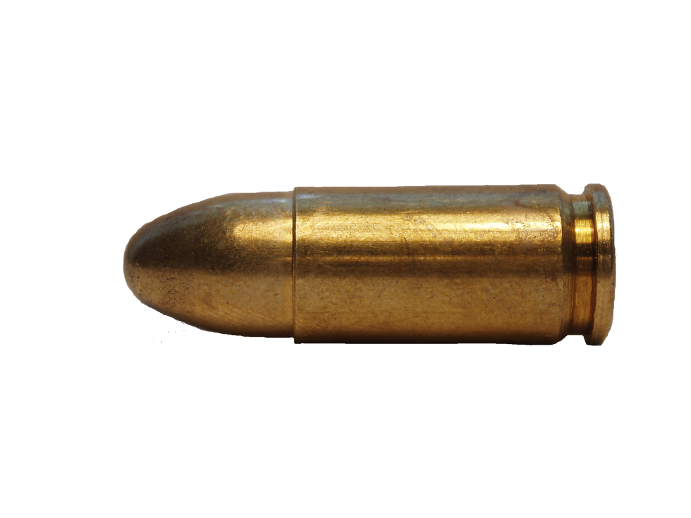

Grass background:



Tank Player Mesh:

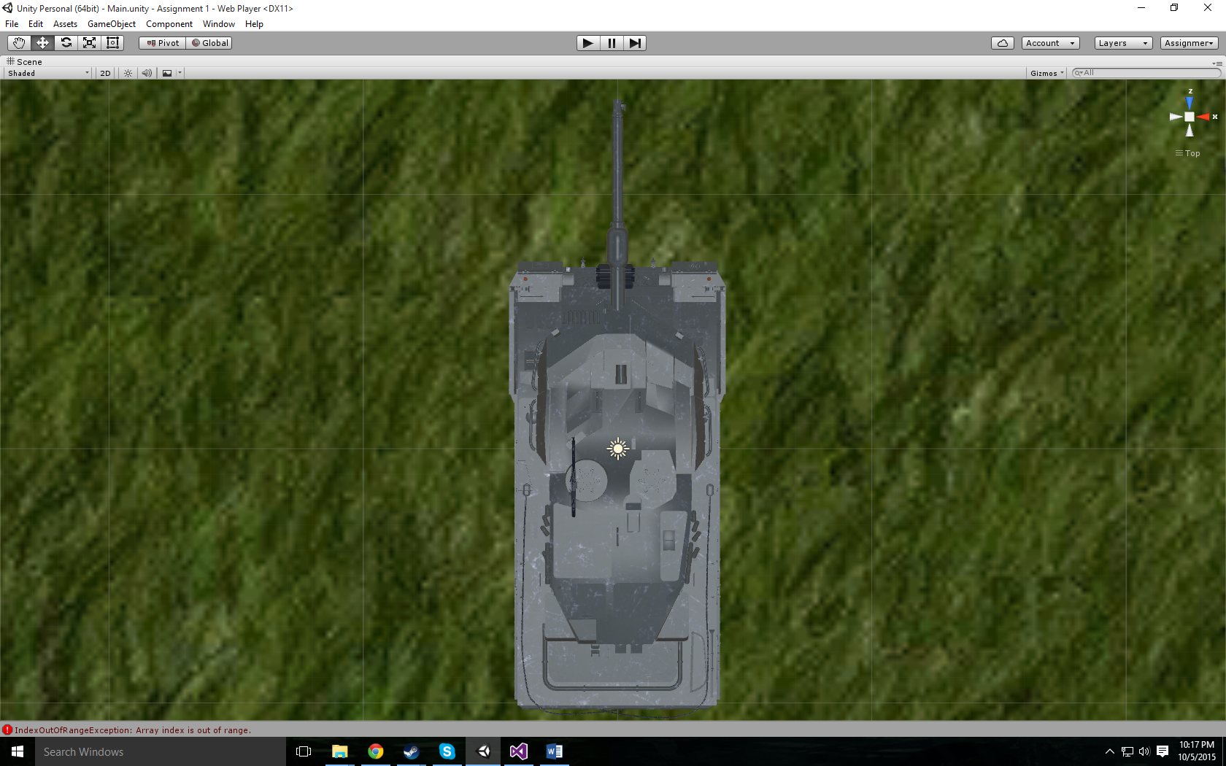

Bomb Enemy Mesh:

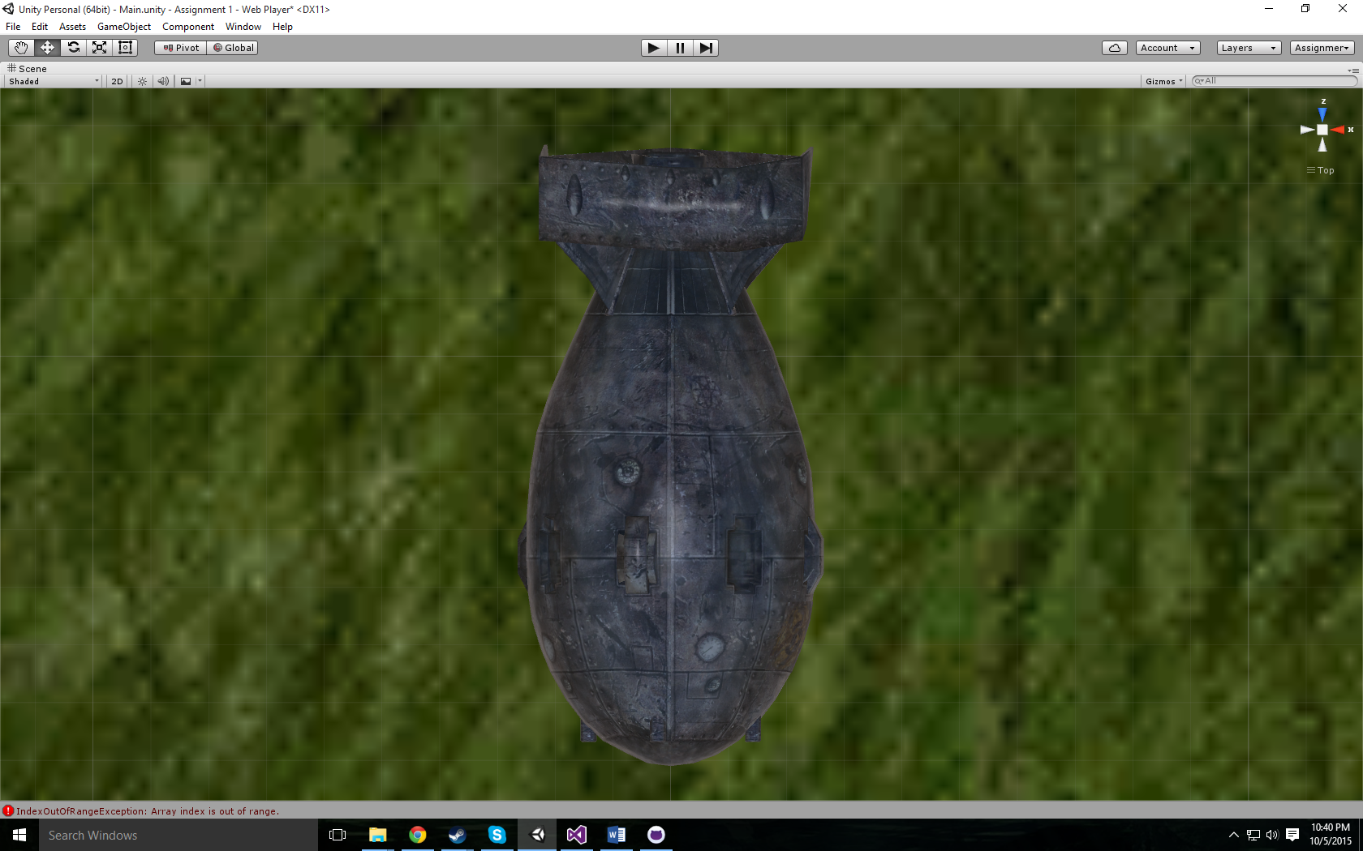

Wrench Mesh:

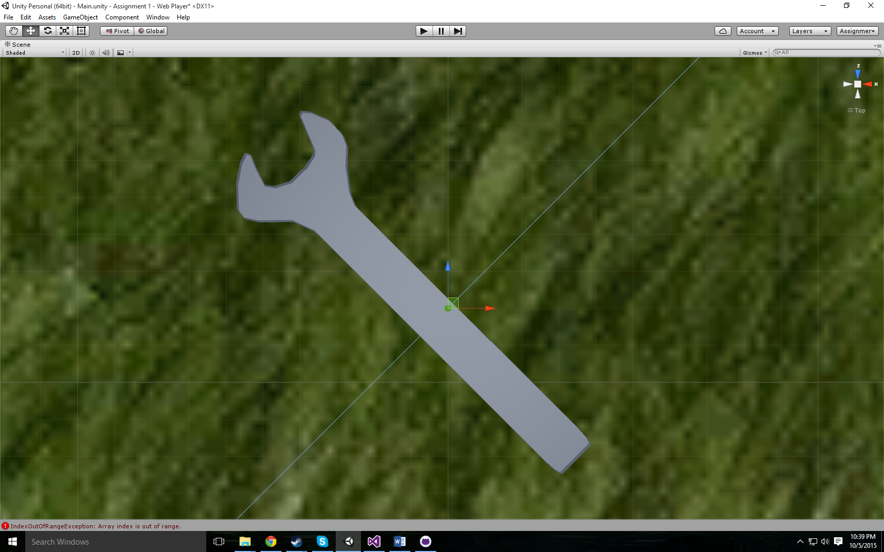

**All Assets Used:**

<http://tf3dm.com/3d-model/leopard-2a6-mbt-24898.html>

<http://pngimg.com/upload/bullets_PNG1468.png>

<http://i627.photobucket.com/albums/tt356/AJLblendMASTER/Textures/Grass_Color.jpg>

<http://tf3dm.com/download-page.php?url=megaton-bomb-21965>

<http://tf3dm.com/3d-model/wrench-28552.html>

<http://www.freesfx.co.uk/>